CS628 Full-Stack Development – Web App
HOS08A: Full-Stack Web Application Part 1 - Backend

Created by Veerendra Jagatha on August 9, 2023
Reviewed by Sumit K C on March 26, 2026
Enhanced by Clark Ngo on June 6, 2026
Reviewed by Harrison Le, June 9, 2026
Reviewed by Divakar Reddy Ravi, August 20, 2026

School of Technology & Computing (STC)
City University of Seattle (CityU)

Before You Start
- Screenshots may be different from your environment.
- The directory path shown in screenshots may be different from yours.
- The steps might have subtle discrepancies. Please use your best judgment while completing each step in this cookbook-style tutorial.
- Some steps may not be explained in detail. If you are not sure what to do:
- Consult the resources from the course.
- If you cannot solve the problem after a few tries (usually 15 -30 minutes), ask a TA for help.

Readings and Examples:
- Visit the CS 628 Repository for Examples.
  - Select the related module.
  - Visit the README.md file.
  - Find examples for your practice.

Learning Outcomes
- Section 1: Spec-driven Development
- Optional Section: Building with Your AI Coding Assistant
- Section 2: Accessing GitHub Codespaces.
- Section 3: Setting up a backend web app
- Section 4: Setting up a connection to MongoDB Atlas
- Section 5: Setting up Server API Endpoints
- Section 6: Testing the API Endpoints with Postman
- Section 7: Pushing your work to GitHub.

Upload the following to your GitHub Repository generated from GitHub Classroom
      - Upload DESIGN_DOC.md
      - The screenshot of your ‘01 Node Server’ as ‘01_node_server_firstname_lastname.png’ by using your first and last name.
- The screenshot of your ‘02 Postman Post’ as ‘02_postman_post _firstname_lastname.png’ by using your first and last name.
- The screenshot of your ‘03 Postman Get’ as ‘03_postman_get_firstname_lastname.png’ by using your first and last name.
- The screenshot of your ‘04 Postman Delete’ as ‘04_postman_delete _firstname_lastname.png’ by using your first and last name.
- The screenshot of your ‘05 Postman Update’ as ‘05_postman_update _firstname_lastname.png’ by using your first and last name.

Section 1: Spec-driven Development

Section 1.1: The Client Conversation / Scenario
Read this thread carefully. All file names, routes, environment variables, ports, and Postman test cases are embedded.

📌 5 screenshot deliverables from Postman tests — all embedded in the conversation below.

👩‍💼 Maria Chen — Product Manager | Today at 9:00 AM

Team — we need the backend for our employee records application. The backend is a Node/Express REST API connected to MongoDB Atlas. Here's the full scope:
- Create a backend/ folder. Use ES Module syntax (.mjs files, not .js).
- Main server file: server.mjs. Runs on port 5050.
- MongoDB Atlas connection string stored in config.env as ATLAS_URI.
- Environment loaded via loadEnvironment.mjs using dotenv.
- Connection logic in db/conn.mjs.
- Routes in routes/record.mjs — CRUD on a 'records' collection.
- Test all 5 operations via Postman: POST (CreateRecord), GET (GetRecords), DELETE (DeleteRecord), PATCH (UpdateRecord).

👨‍💻 Alex Rivera — Developer | Today at 9:15 AM

Got it. What are the exact API paths? And what fields does a record have?

🧑‍🔧 Sam Park — Tech Lead | Today at 9:22 AM

Routes all under /record:
- GET /record → returns all records array
- GET /record/:id → single record by MongoDB _id
- POST /record → create new record. Body: { name, position, level }
- PATCH /record/:id → update fields. Body: partial fields
- DELETE /record/:id → delete by id
Test data to insert via Postman: John (first), then Sean, then Matthew. Update Matthew to 'Senior Software Engineer 2'. Delete John. Postman collection name: hos08.
Make port 5050 Public in Codespaces before Postman can reach it. Screenshots:
- 01_node_server_firstname_lastname.png — terminal showing server started
- 02_postman_post_firstname_lastname.png — POST creating first record
- 03_postman_get_firstname_lastname.png — GET returning all records
- 04_postman_delete_firstname_lastname.png — DELETE removing John
- 05_postman_update_firstname_lastname.png — PATCH updating Matthew

Section 1.2: Requirements Gathering
Use Gemini or Claude to formally extract requirements from the Section 1 scenario.

Exercise 1.2.1 — Actors & Goals
💬 Prompt: "From this scenario, identify all system actors (users, services, external systems) and their primary goals. Format as a table: Actor | Type | Primary Goal. Then paste the Section 1 conversation."

📝 Add your verified actor table to DESIGN_DOC.md Section 4 — Actors.

Exercise 1.2.2 — Functional Requirements
💬 Prompt: "Extract all functional requirements. Format each as: 'The system shall...' Organize by component."

Expected requirements include:
- The system shall start an Express server on port 5050.
- The system shall load environment variables from config.env via loadEnvironment.mjs.
- The system shall connect to MongoDB Atlas using the ATLAS_URI connection string.
- The system shall implement GET /record to return all documents from the records collection.
- The system shall implement GET /record/:id to return a single record by MongoDB ObjectId.
- The system shall implement POST /record to create a new record with name, position, level fields.
- The system shall implement PATCH /record/:id to update specified fields of an existing record.
- The system shall implement DELETE /record/:id to remove a record by ObjectId.
- The system shall configure CORS middleware to allow cross-origin requests.

Exercise 1.2.3 — Non-Functional Requirements
💬 Prompt: "Extract non-functional requirements: performance, security, privacy, maintainability. Describe each constraint and why it matters."

Exercise 1.2.4 — Open Questions
💬 Prompt: "What are at least 5 unresolved engineering questions not answered in the conversation?"

Write at least 3 original open questions (not AI-generated) in Section 11 of your DESIGN_DOC.md.

Section 1.3: Creating the Design Document with AI

🚫 Do NOT start coding until your DESIGN_DOC.md is complete and reviewed.

Step 1.3.1 — Create the File
# At your project root:
touch DESIGN_DOC.md

Step 1.3.2 — Generate Each Section with AI
Section # | AI Prompt Template
1. Problem Statement | Write a 2-sentence problem statement for this system. Avoid buzzwords.
2. Goals | List 4-6 concrete measurable goals based on the conversation.
3. Non-Goals | List 3-4 explicit non-goals — things deliberately NOT built this sprint.
4. Actors | Describe all actors and their roles.
5. Functional Requirements | Generate 'The system shall...' statements organized by component.
6. Non-Functional Requirements | List performance, security, privacy, and maintainability constraints.
7. Architecture Overview | Draw an ASCII text diagram of the full system data flow.
8. API Design | Document all API endpoints: path, method, request body, response, status codes.
9. Data Model | Describe the data structures and schemas flowing through the system.
10. Tech Stack Justification | For each technology, write 1-2 sentences explaining WHY it was chosen.
11. Open Questions | List at least 5 unresolved questions including your 3 original ones.

Step 1.3.3 — Validate Against Hallucinations
💬 Verification Prompt: "Review this DESIGN_DOC.md for technical accuracy. Flag incorrect port numbers, wrong API paths, missing configurations, or misnamed technologies. Cross-reference: [paste Section 1]."

Section 2: Accessing GitHub Codespaces

Follow the instructions here.

Optional Section: Building with Your AI Coding Assistant

You will now use your DESIGN_DOC.md as the primary context source for your AI coding assistant. Choose your platform below and follow the corresponding workflow. The milestones are identical regardless of which tool you use.

Platform Workflows — Choose Your Tool

Option A: Cursor (AI-Native IDEs)
- Open your project folder in Cursor.
- Open the AI Chat panel.
- Add your DESIGN_DOC.md as context: type @DESIGN_DOC.md in Cursor's chat input.
- Paste each milestone prompt below into the chat to generate code step by step.

Option B: VS Code + GitHub Copilot
- Open the Chat view (Cmd+Shift+I or click the chat icon in the Activity Bar).
- Type @workspace at the start of your prompt so Copilot indexes your project files including DESIGN_DOC.md.
- Provide the milestone instructions below to generate or modify files inline.

Milestone 1 — Backend Scaffolding + Server Startup
💬 Milestone Prompt: Create backend/ folder. Create loadEnvironment.mjs (imports dotenv, loads config.env). Create config.env with ATLAS_URI. Create db/conn.mjs that connects to Atlas using MongoClient. Create server.mjs: import express and cors, set port from process.env.PORT or 5050, mount routes/record.mjs at /record, start server. Run: node server.mjs

📸 SCREENSHOT REQUIRED — 01_node_server_firstname_lastname.png — terminal shows 'Server is running on port: 5050'

Milestone 2 — CRUD Routes in record.mjs
💬 Milestone Prompt: Create routes/record.mjs with Express Router. Define: GET / (find all), GET /:id (findOne by ObjectId), POST / (insertOne with name/position/level), PATCH /:id (updateOne with $set), DELETE /:id (deleteOne). Export router. Make port 5050 Public in Codespaces Ports tab.

📸 SCREENSHOT REQUIRED — No screenshot yet — test in next milestone.

Milestone 3 — Postman Testing — All 5 Operations
💬 Milestone Prompt: In Postman, create collection 'hos08'. Add requests: CreateRecord (POST), GetRecords (GET), DeleteRecord (DELETE), UpdateRecord (PATCH). Insert John, Sean, Matthew. Then GET all, DELETE John, PATCH Matthew to 'Senior Software Engineer 2'.

📸 SCREENSHOT REQUIRED — 02_postman_post, 03_postman_get, 04_postman_delete, 05_postman_update — each firstname_lastname.png

Continue from Accessing GitHub Codespaces if optional section was skipped

Section 3: Setting up a backend web app

“Node.js” is an open-source, server-side runtime environment that allows you to execute JavaScript code on the server. It is designed to enable developers to build scalable and efficient network applications.

- Let us now check the node version in the current Codespaces.

- Once your Codespace is open, you can access an integrated terminal.

- In the terminal, you can use the following command to check the installed Node.js version:
>>node -v
or
>>node --version
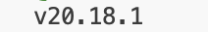

- In this HOS, we will set up the backend for our application. To develop a server-side web application, create a folder named "backend" under the root directory in Codespaces. Then, navigate to that folder using the following commands.
>> cd backend

- We will also install the required dependencies. Run the following command in the terminal.
>> npm install mongodb express cors dotenv

The command above installs the following dependencies:
- The installation of MongoDB includes the MongoDB database driver, enabling your Node.js applications to establish connections with the database and manage data effectively.
- When you install "express," you add the Node.js web framework to your environment. Express is a rapid, versatile, streamlined web application framework tailored to Node.js. It equips developers with a toolkit and capabilities to craft web and API applications.
- The installation of "cors" introduces a Node.js package that facilitates cross-origin resource sharing, allowing resources from different origins to be shared securely.
- By installing "dotenv," you install a module designed to load environment variables from a '.env' file into the 'process.env' file. Separating configuration details from the code promotes cleaner and more organized development practices.

- We can check our installed dependencies using the “package.json” file. For example,

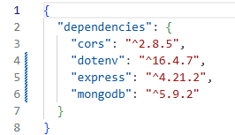

- ~version “Approximately equivalent to version”, will update you to all future patch versions, without incrementing the minor version. ~1.2.3 will use releases from 1.2.3 to <1.3.0.
- ^version “Compatible with version”, will update you to all future minor/patch versions, without incrementing the major version. ^1.2.3 will use releases from 1.2.3 to <2.0.0. (https://stackoverflow.com/questions/22343224/whats-the-difference-between-tilde-and-caret-in-package-json)

- Now let’s create a file called “server.mjs” with the following code.

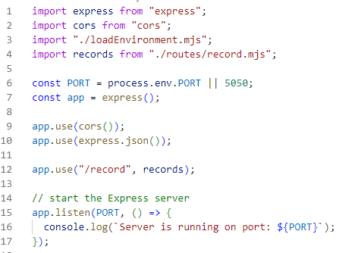

If you're wondering about the meaning of .mjs, it's important to note that both “.js” and “.mjs” files are utilized in Node.js to run JavaScript code. Nevertheless, they diverge significantly into how they manage modules. In “.js” files, Node.js employs the CommonJS module system, requiring the use of require () to import modules and module.exports to export them. Conversely, “.mjs” files utilize the ES (ECMAScript) Modules (ESM) system, employing import and export statements for handling modules.(https://stackoverflow.com/questions/57492546/what-is-the-difference-between-js-and-mjs-files)

- In this code, we are importing express and cors.
“Const port process.env.PORT” will access the port variable from the “config.env.

Section 4: Setting up a connection to MongoDB Atlas

- We first need the connection string to set up a connection to MongoDB Atlas. Log in to your MongoDB Atlas account. And then, under the overview section, click Connect and then Drivers.

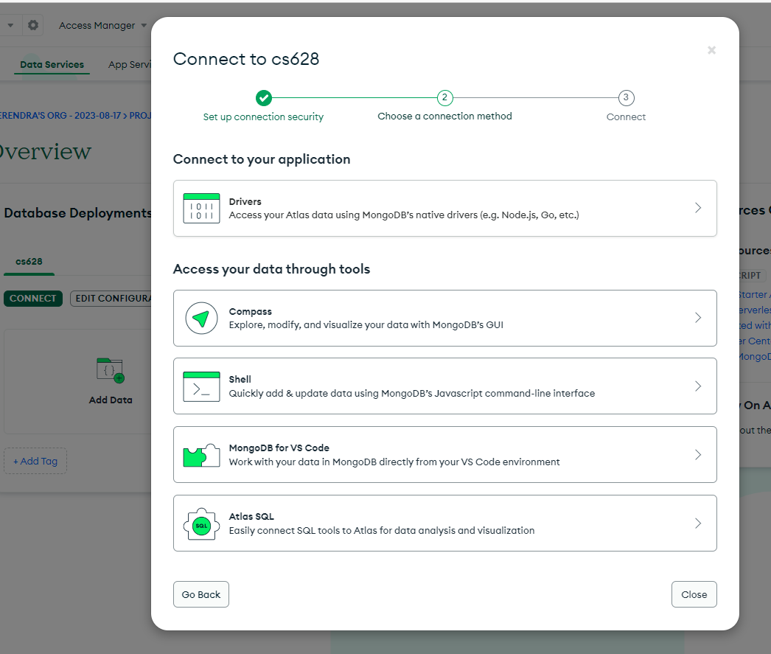

- Copy the connection string, update your password like we did in our previous module, and save it. We will use it in the next steps.

- Having obtained the connection string, return to the 'backend' directory and create a 'config.env' file. This file assigns the connection string to a fresh variable named ATLAS_URI, as shown below.

- You will additionally require a module for loading this environment variable. Create a `loadEnvironment.mjs` file in the backend directory and input the provided code.

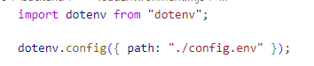

- Create a new directory named 'db' inside the backend directory. Inside this directory, create a file named 'conn.mjs'. Within 'conn.mjs', insert the following code to establish a connection with the database.

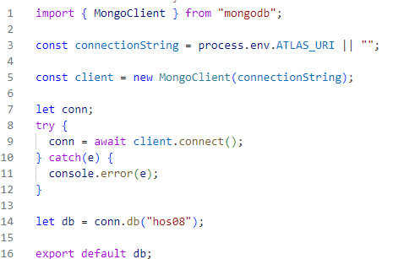

Section 5: Setting up Server API Endpoints

- Return to the "backend" directory and generate the required directory and files using the following commands in the terminal for setting up API Endpoints:

>> cd ../backend

>> mkdir routes

>> touch routes/record.mjs

We use the Linux touch command to update the timestamps on existing files and directories as well as create new, empty files. (https://linuxize.com/post/linux-touch-command/#google_vignette)

- Now insert the code in your “record.mjs” from the hos-examples file “record.mjs.”
The code defines a router with various routes for performing CRUD (Create, Read, Update, Delete) operations on a collection named "records."

- Verify folder and file structure:

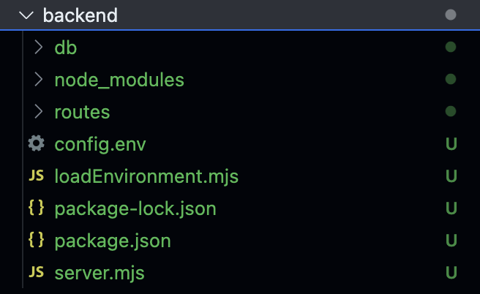

Express Router is a feature provided by the Express web application framework in Node.js that allows you to modularize and organize your application's routes and middleware in a structured manner.

- The first route responds to a GET request at the root path ("/") and retrieves all records from the "records" collection.
- The second route handles a GET request with a parameterized route ("/:id"), fetching a single record based on the provided ID.
- The third route deals with a POST request, allowing the creation of a new record in the "records" collection.
- The fourth route responds to a PATCH request ("/:id") and updates a record based on the provided ID with the data in the request body.
- The fifth route handles a DELETE request ("/:id"), deleting a record from the "records" collection based on the given ID.

- Let us now run the server using the following command in the Terminal.
>> node server.mjs

If everything works as expected, you will see this message in the terminal,

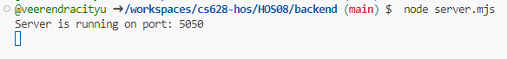

Take a screenshot of your ‘01 Node Server’ as ‘01_node_server_firstname_lastname.png’ by using your first and last name.

- Now click on the Ports tab beside the Terminal and open the local address in the new tab.

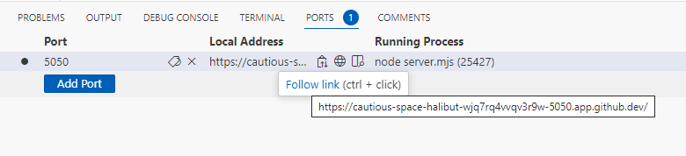

You will see the following message,

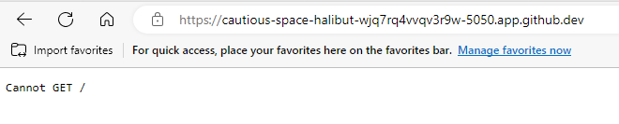

- In our “server.mjs” file, we are using “/record” to mount the records router to a specific route path within the Express application. This means that whenever a request is made to the "/record" route, the functionality defined in the records router will be executed.

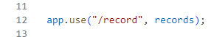

- Append “/record” to the above URL and refresh the browser. The error will go away, and an empty array will be returned. This is expected as we have not inserted any records into our database.

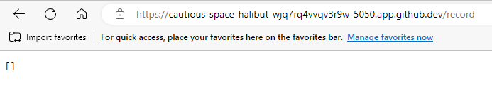

Section 6: Testing the API Endpoints with Postman

- Let us now test our API using the postman tool. You may choose to download and install the postman desktop app or use postman web from this link.

Postman is a popular tool for testing, developing, and documenting APIs. It simplifies the process of working with APIs by providing a user-friendly interface that allows developers to make HTTP requests, view responses, and test various API functionalities.

- You can create an account or use Google for signing in the postman application. After you sign in, you will see the following screen. In Postman, select “My Workspace” from the “Workspaces” menu.

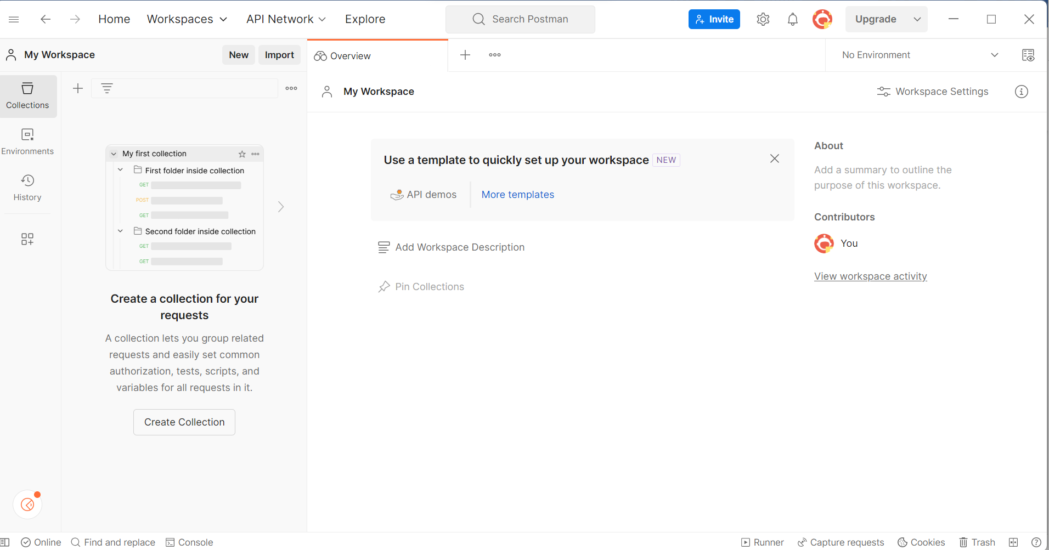

- Before we start making the request, we need to make the port public for postman to access it.

- In the ports tab of GitHub Codespaces in your VSCode, make it public as shown below by right clicking on the port number 5050.

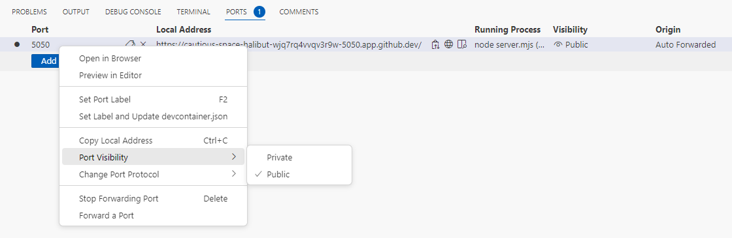

- Start by creating a collection and give it a name “hos08.” After this, click on Add a request to create your first request.

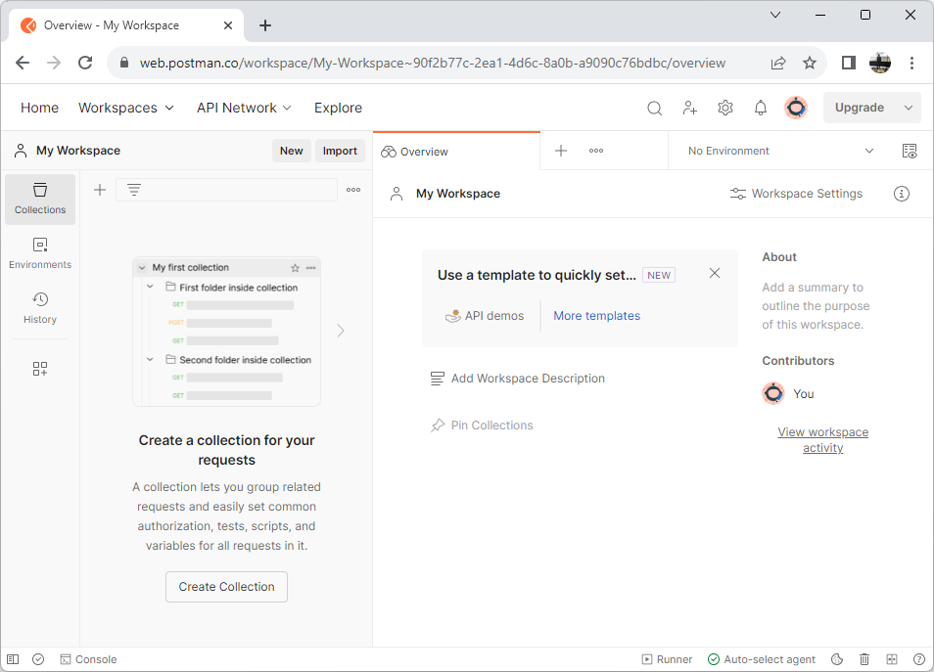
1
2

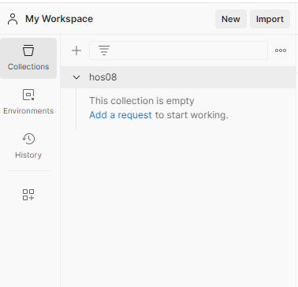

CreateRecord:

- Let us start by inserting a few records into the database. Name your request as CreateRecord. We will make a POST request to the URL we used in the browser earlier.

- Under the “Headers” tab, use “Content-Type” for key and “application/json” for value.

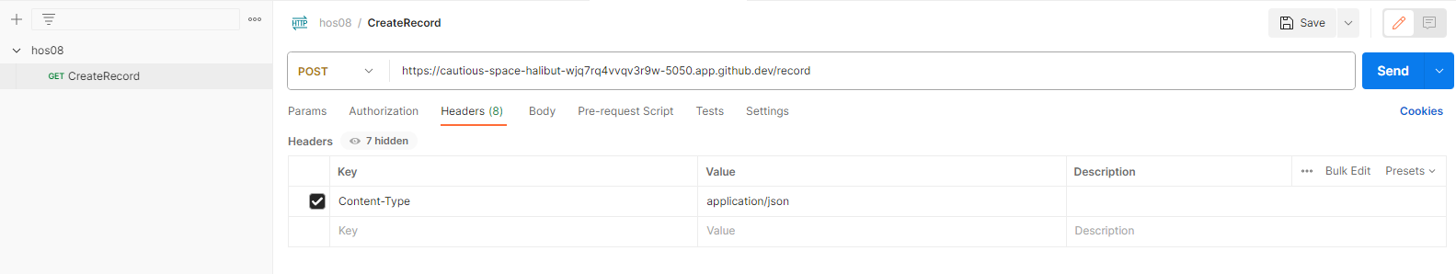
1
2
3
4

- Under the “Body” tab, use the request body as shown below to insert the first record and select JSON as raw data.

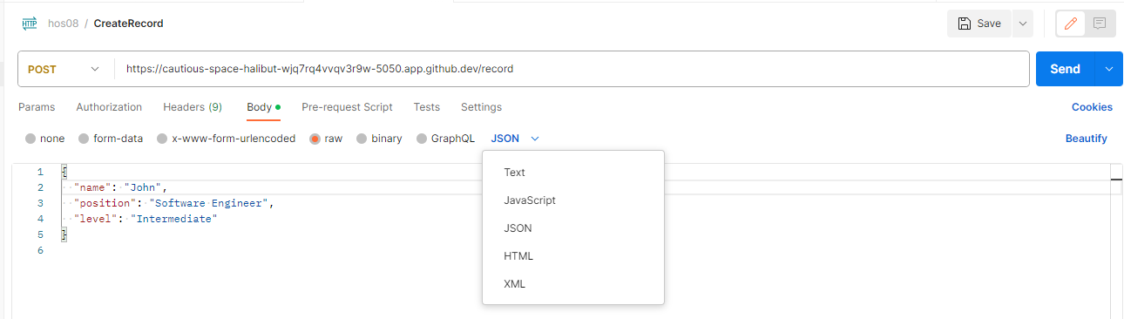
1
2
3
4

- Click on Send and you will see the response body as shown below. Our first record is inserted.

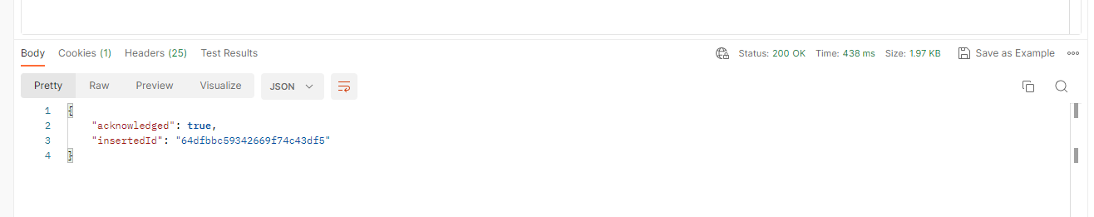

Take a screenshot of your ‘02 Postman Post’ as ‘02_postman_post _firstname_lastname.png’ by using your first and last name.

- Verify the data on the MongoDB side. Go to the cluster and click on browse collections.

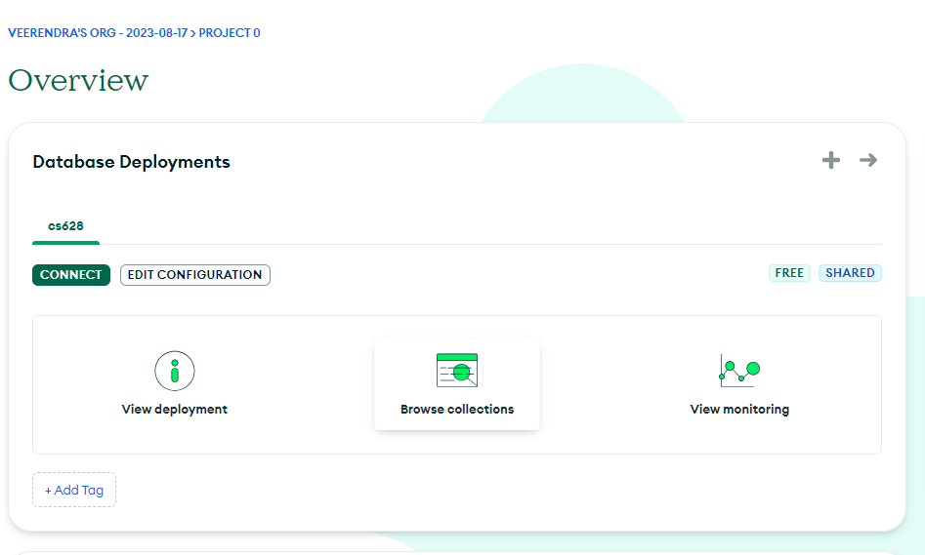

- You will see the record we just inserted.

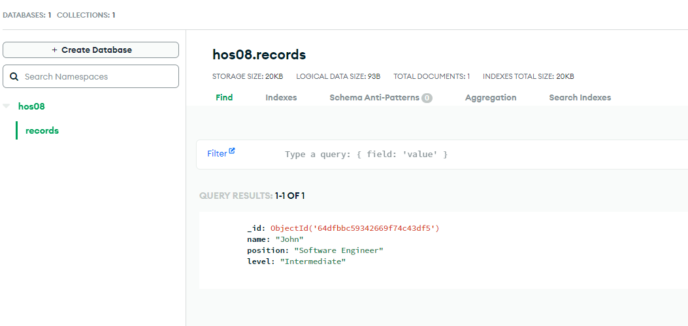

- Test your backend (server-side) web application. You will see the record you just inserted.

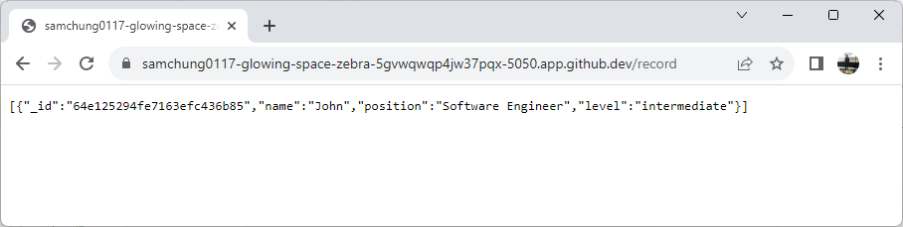
You can now change the request body in the postman tool and insert multiple records in similar fashion.

- Let’s add “Sean” and “Matthew” to your MongoDB through Postman.

- Create Sean’s record.

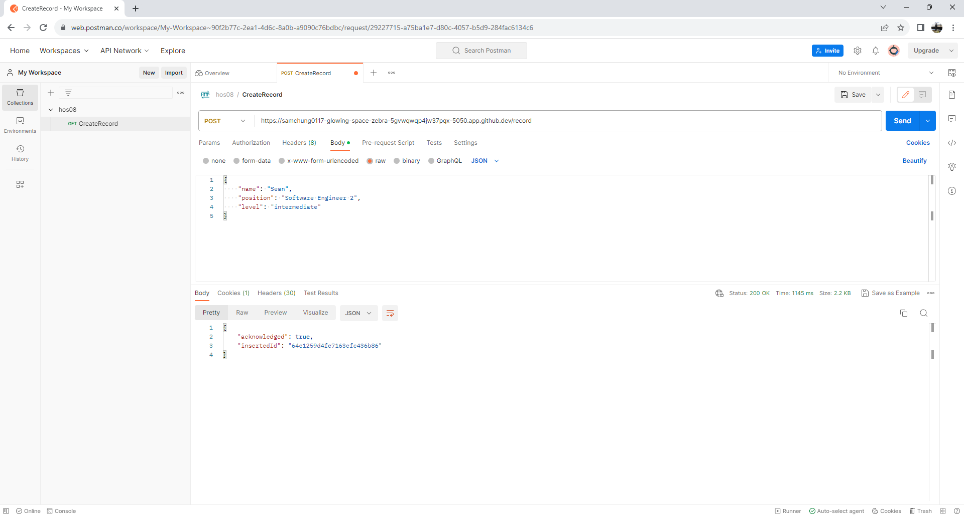

- Check your MongoDB.

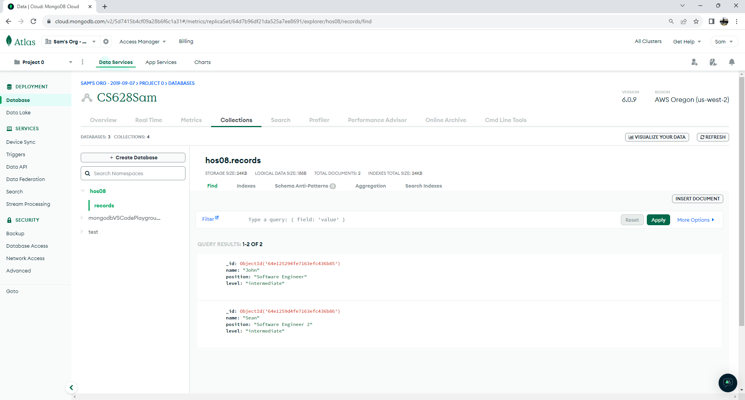

- Check your backend web app.

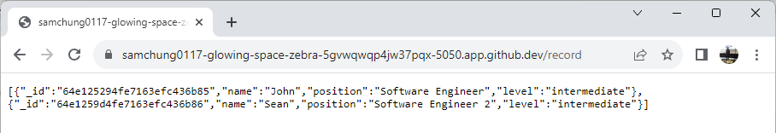

- Create Matthew’s record.

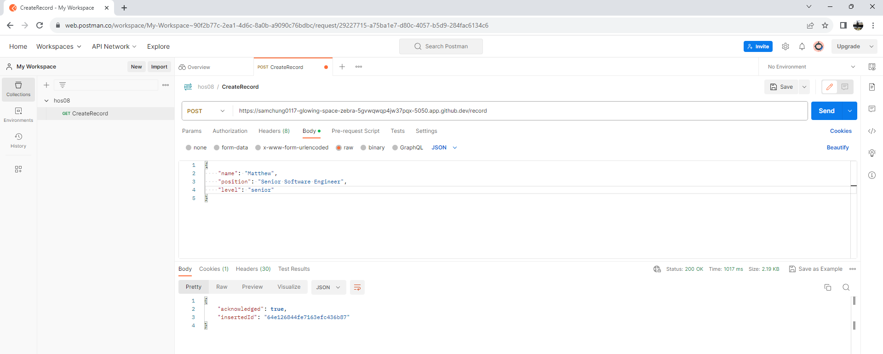

- Check your MongoDB.

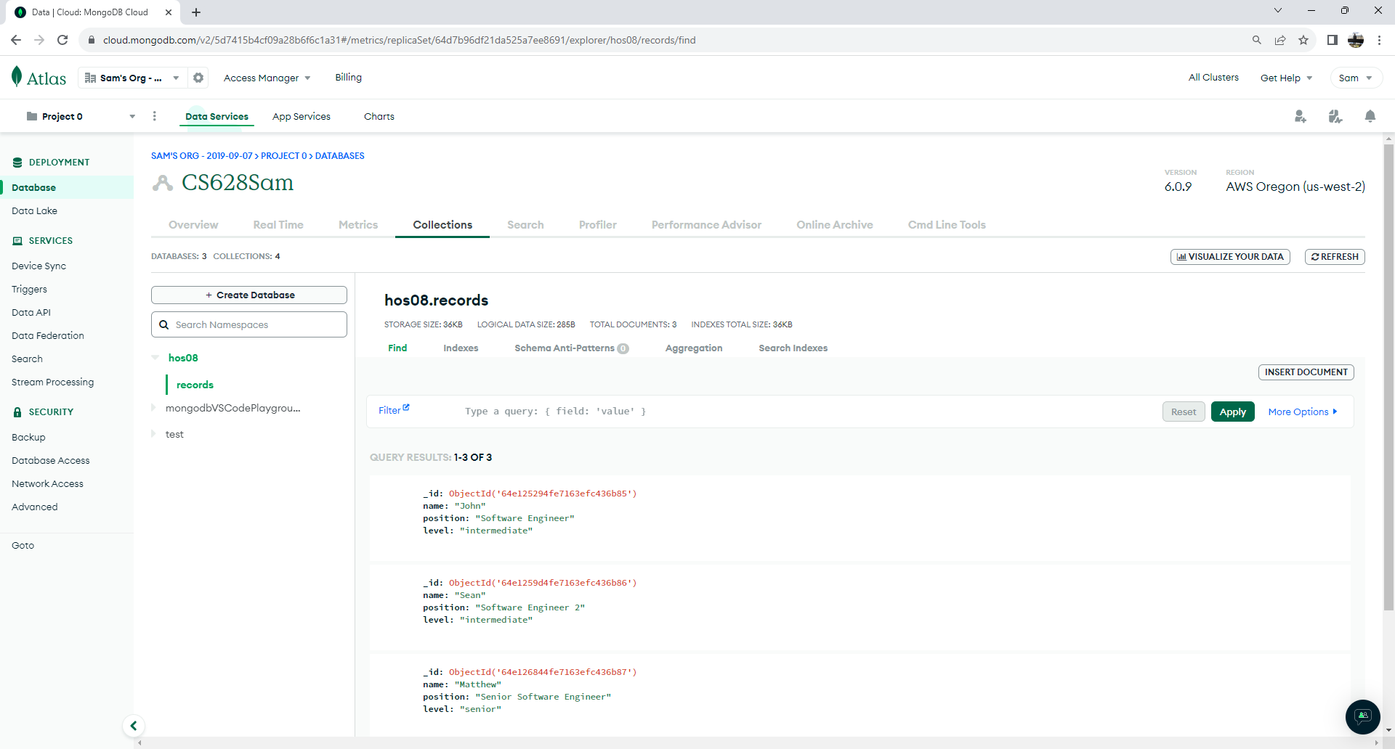

- Check your backend web app.

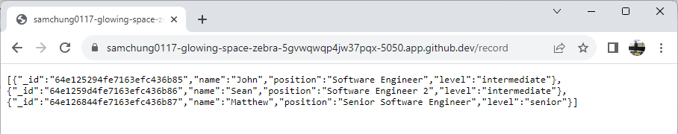

GetRecords:

- Create another request under the collections and name it “GetRecords.” Use GET method and the URL obtained earlier to make the request as shown below. Observe the records returned in response.

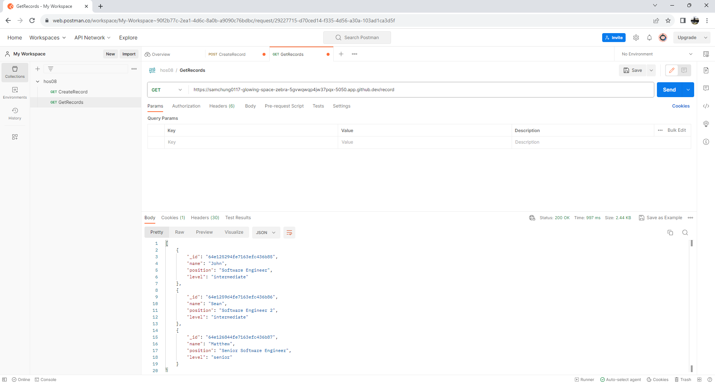
1
2
3

Take a screenshot of your ‘03 Postman Get’ as ‘03_postman_get_firstname_lastname.png’ by using your first and last name.

DeleteRecord:

- Similarly, we can create another request to delete a record. Use DELETE HTTP method this time and you need to append the id in the URL after /record. You can get the id for “John” to delete from earlier GetRecords request.

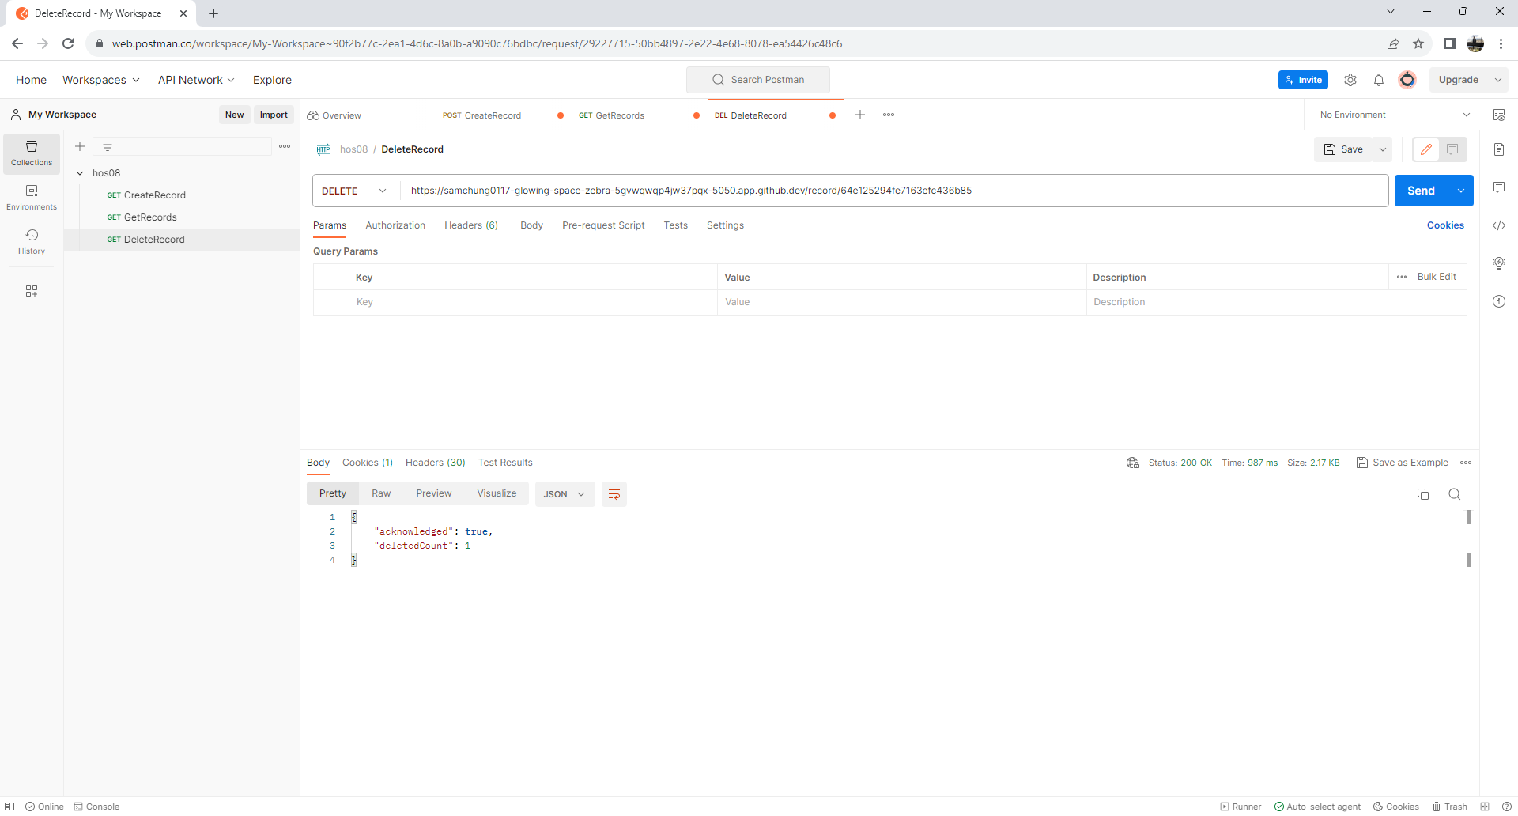
1
2
3
4

Take a screenshot of your ‘04 Postman Delete’ as ‘04_postman_delete _firstname_lastname.png’ by using your first and last name.

- Check your MongoDB.

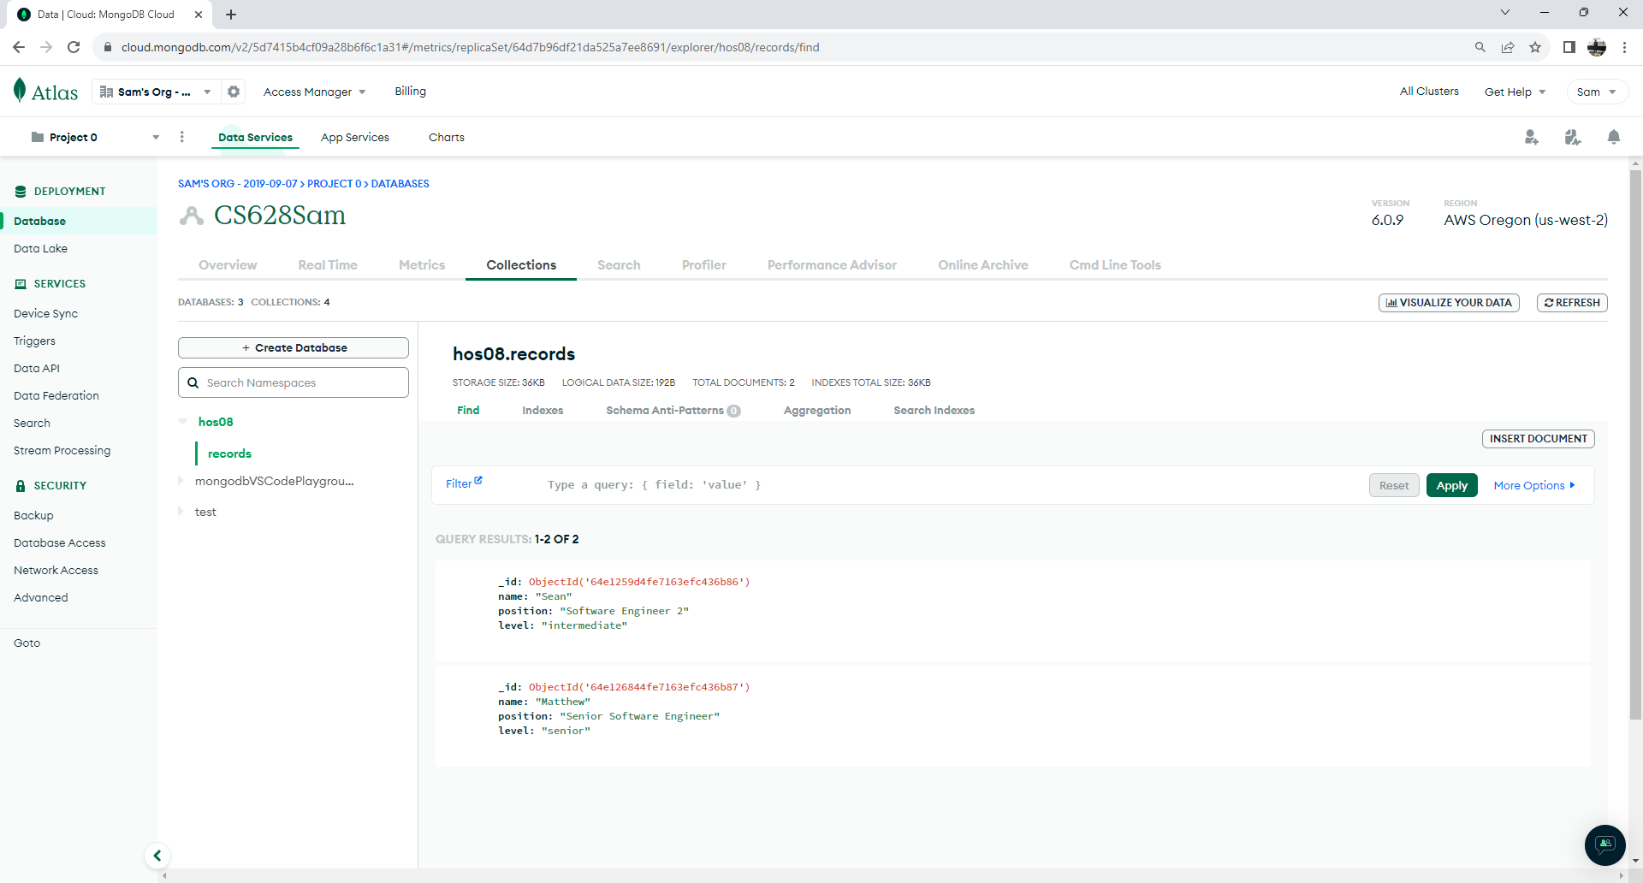

- Check your backend web app.
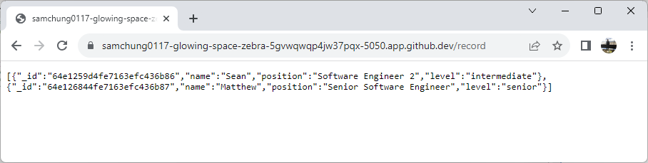

UpdateRecord

- The “UpdateRecord” request simlar to the “CreateRecord” request but with two differences. We will use PATCH HTTP method and pass the id (for example. Matthew) in the URL for the record we are trying to update. Matthew’s position is “Senior Software Engineer 2” Please see below.

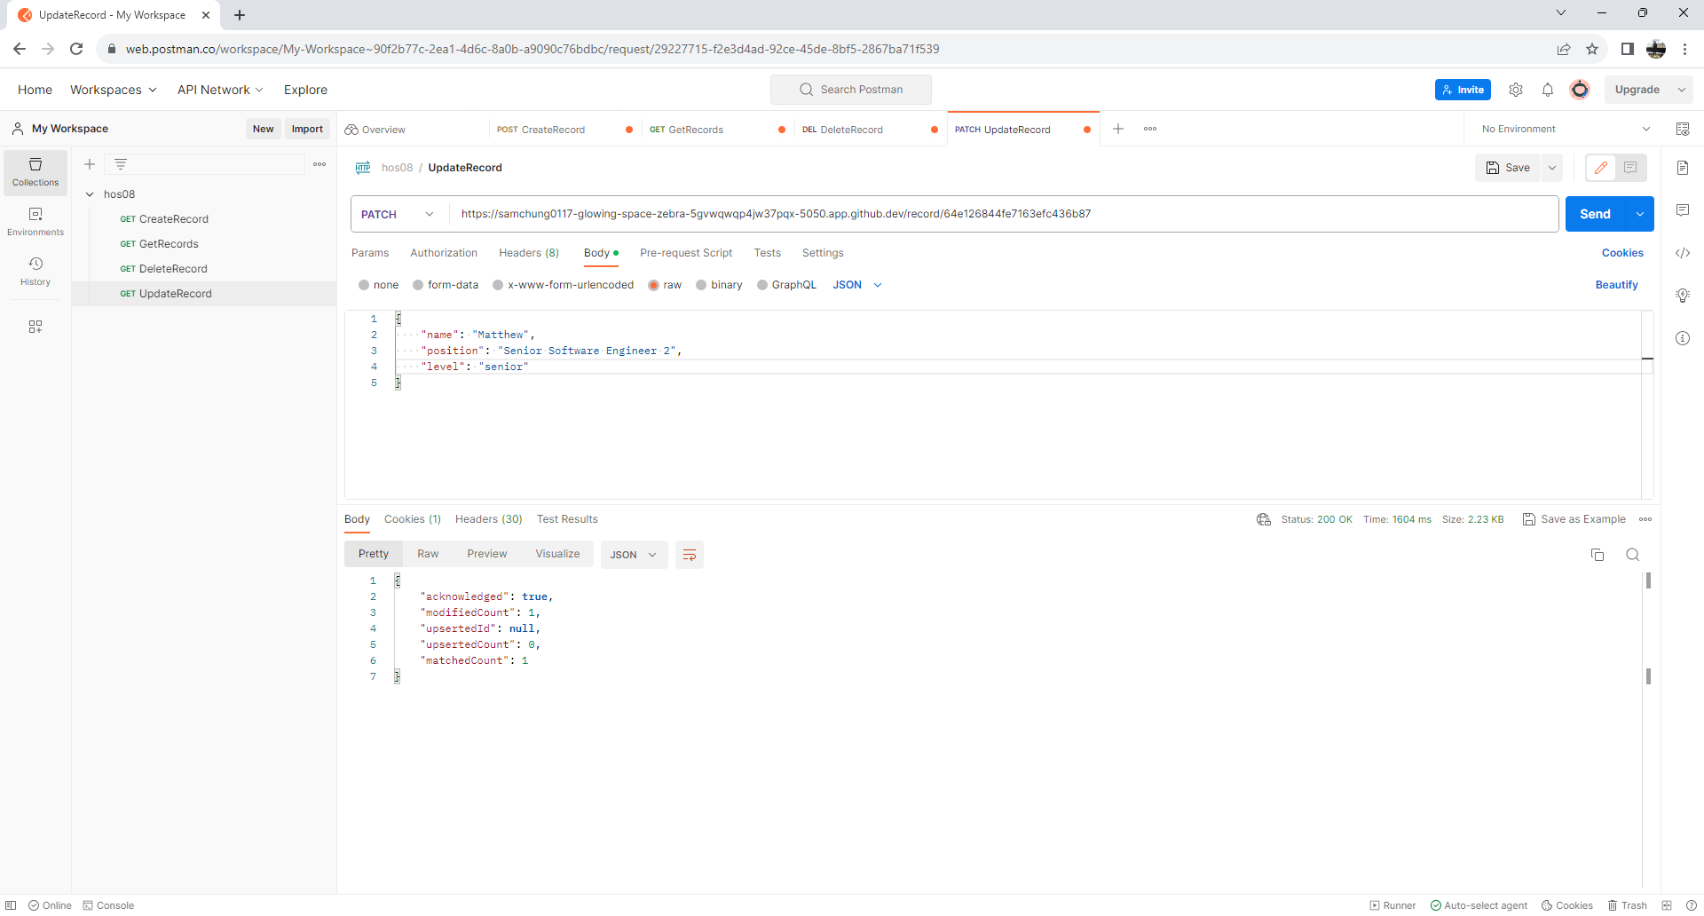
1
2
3
4

Take a screenshot of your ‘05 Postman Update’ as ‘05_postman_update _firstname_lastname.png’ by using your first and last name.

- Check your MongoDB.
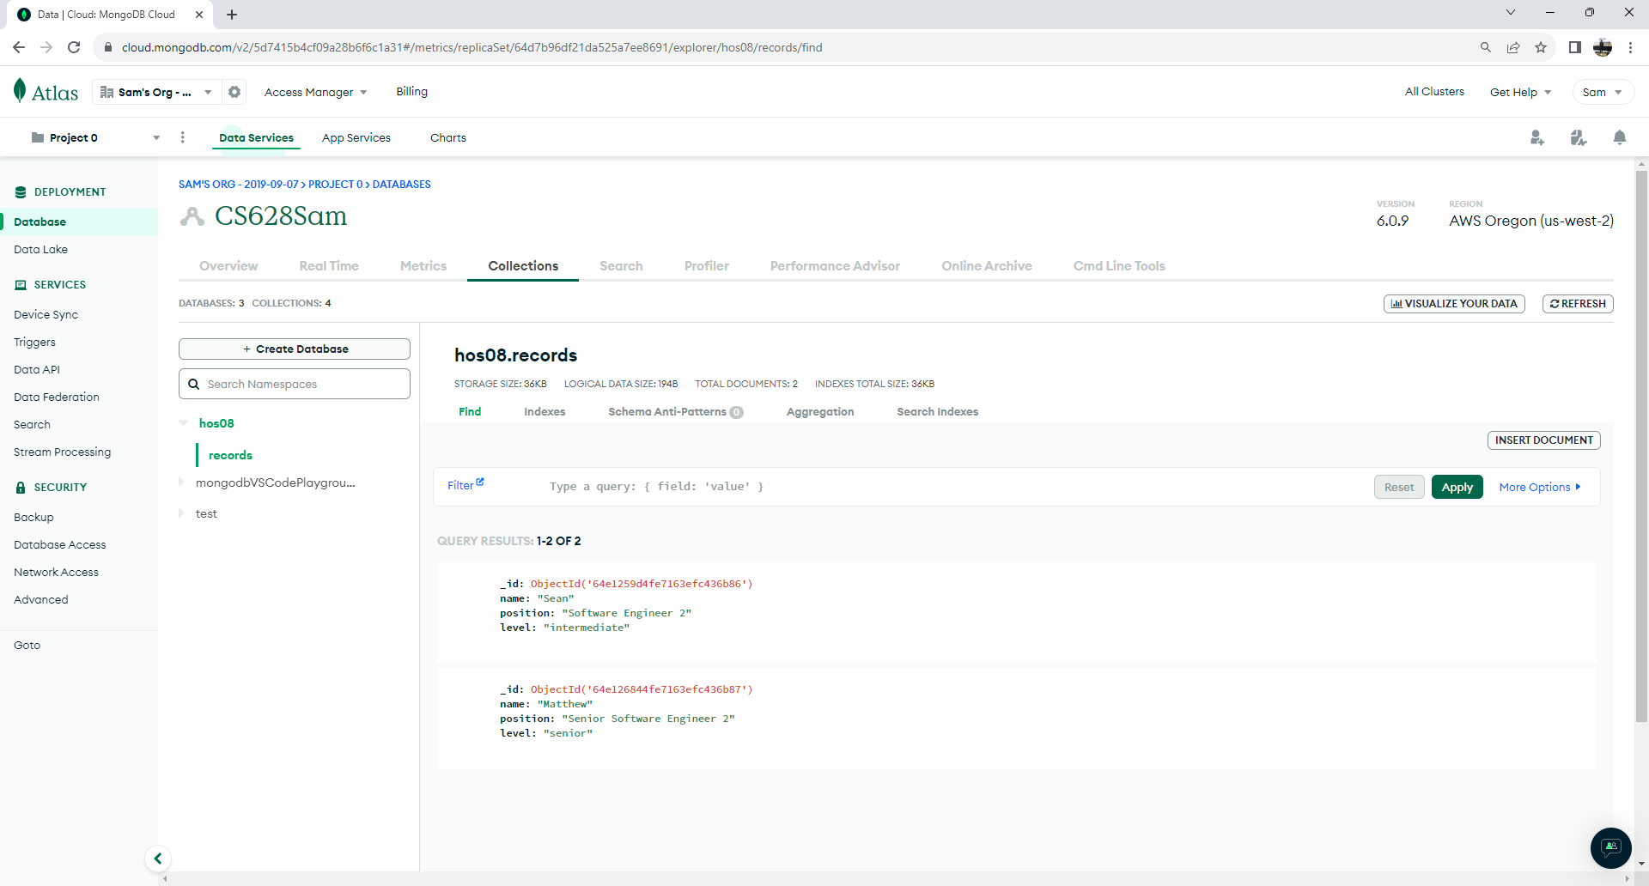

- Check your backend web app.

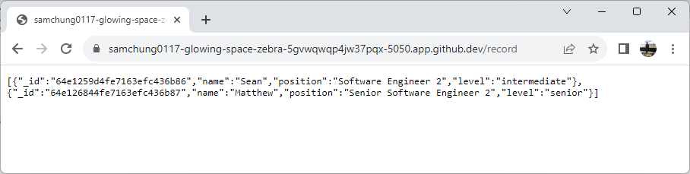

Section 7: Pushing your work to GitHub
How to submit your work in GitHub

